**Team Information**

* **Project Title: ServiceNow Workflow Management System Implementation**
* **Team ID: NM2025TMID15160**
* **Team Size: 4**
* **Team Leader: SHYAM SUNDAR J**
* **Team Member 1: PARASURAMAN N**
* **Team Member 2: SIVA RAJ T**
* **Team Member 3: MARISWARAN V**

**Problem Statement**

**Organizations often face difficulties in managing users, groups, roles, and access permissions in a consistent and secure manner. Without an automated solution, workflows become prone to errors, leading to inefficiency and lack of accountability.**

**Objective**

**The goal of this project is to design and configure a ServiceNow Workflow Management System that streamlines:**

* **User, group, and role management**
* **Table creation and application access**
* **Role-based security through Access Control Lists (ACLs)**
* **Automation of workflows using Flow Designer**

**This ensures structured operations, controlled access, and smooth task execution.**

**Skills Utilized**

* **ServiceNow administration**
* **User, group, and role management**
* **Table and module configuration**
* **Application access management**
* **ACL implementation**
* **Flow Designer automation**

**TASK INITIATION**

**The following milestones outline the step-by-step development of the ServiceNow workflow management system.**

**Milestone 1: Users**

**Activity 1: Create Users**

1. **Log in to ServiceNow.**
2. **In the Application Navigator, go to All → Users.**
3. **Under System Security, select Users.**
4. **Click on New.**
5. **Enter the required details for the first user (e.g., *alice p*).**
6. 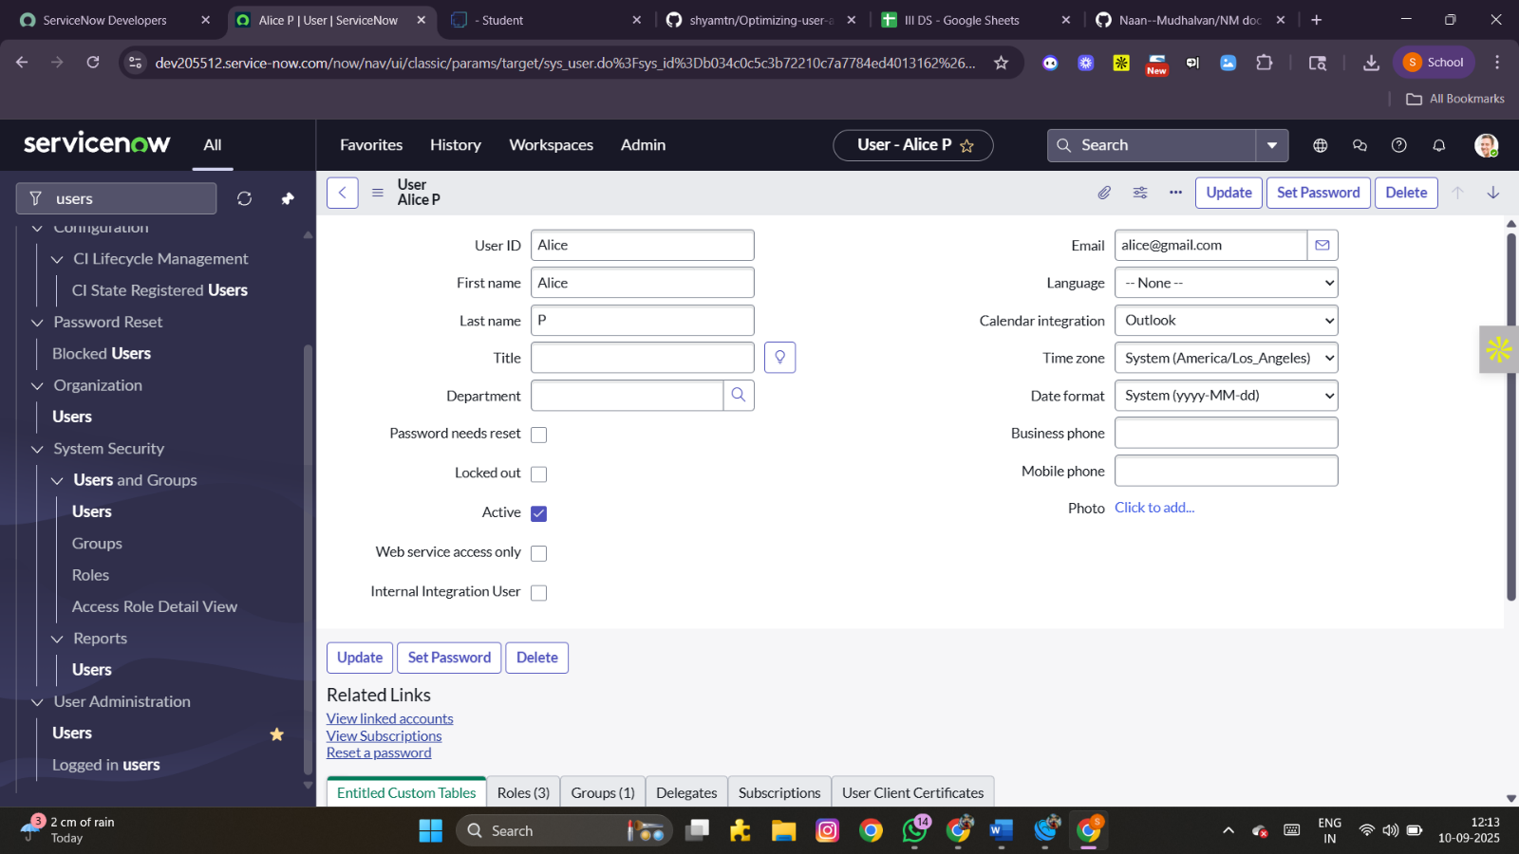**Click Submit.**

**Create a second user:  
7. Add another user (e.g., *bob p*) by repeating the steps above.  
8. Click Submit.**

**Milestone 2: Groups**

**Activity 1: Create Groups**

1. **Open ServiceNow.**
2. **Navigate to All → Groups.**
3. **Under System Security, select Groups.**
4. **Click on New.**
5. **Provide the necessary details to define a group (e.g., *Project Team Group*).**
6. **Click Submit.**

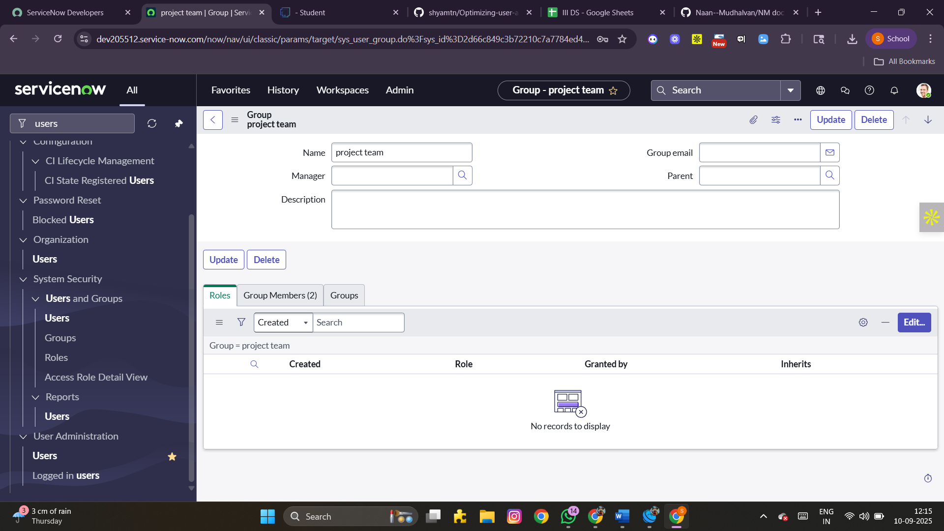

**Milestone 3: Roles**

**Activity 1: Create Roles**

1. **Log in to ServiceNow.**
2. **Go to All → Roles.**
3. **Under System Security, choose Roles.**
4. **Click New.**
5. **Fill in the fields to create a new role (e.g., *Project Manager*).**
6. **Click Submit.**

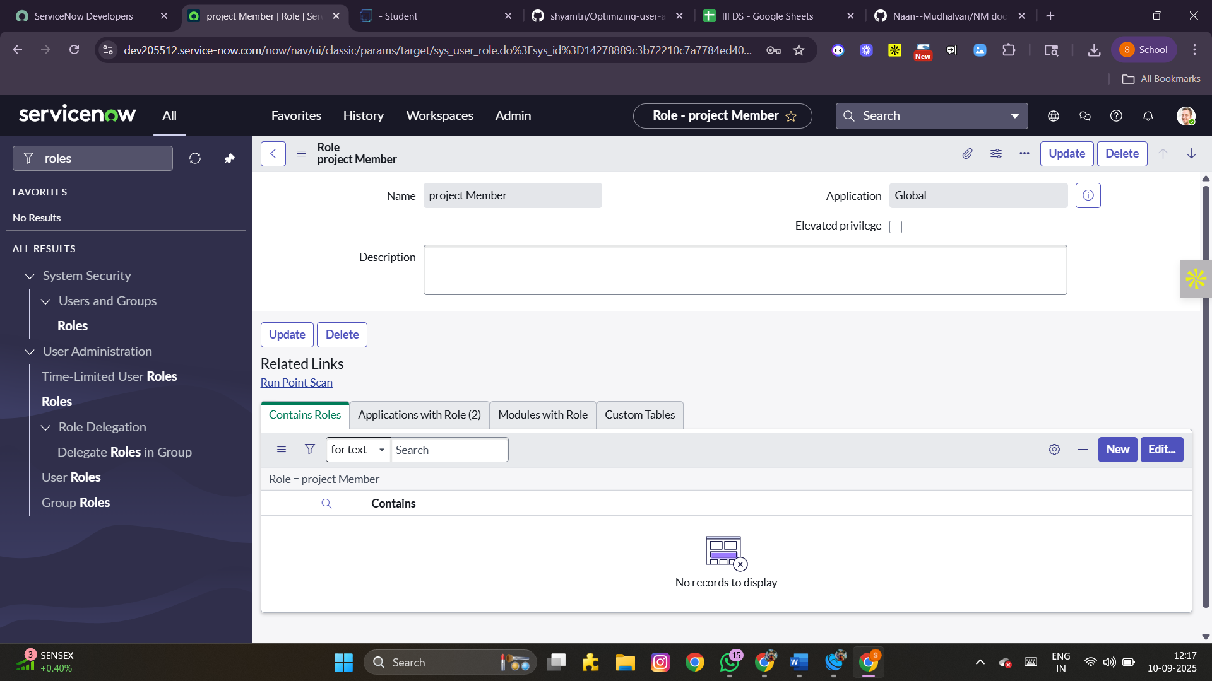 **Create another role:  
7. Add a second role (e.g., *Team Member*).  
8. Click Submit.**

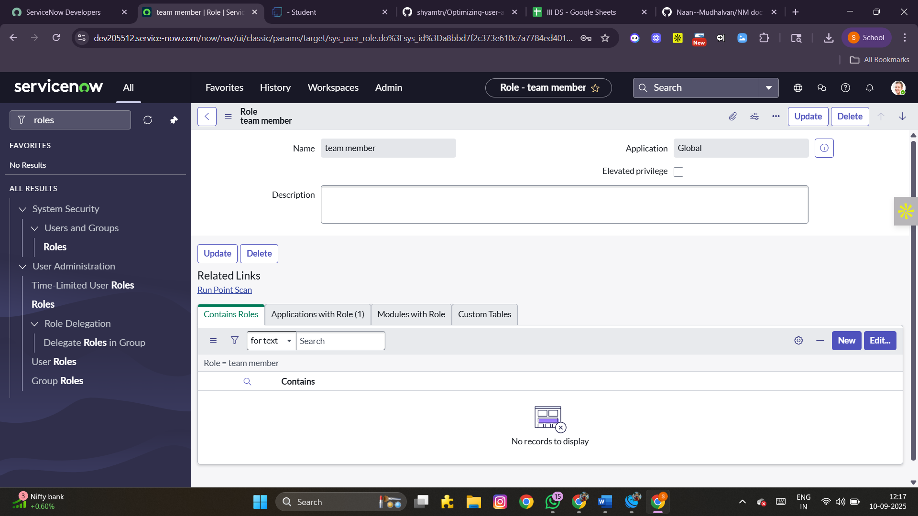

**Milestone 4: Table**

**Activity 1: Create Tables**

1. **Access ServiceNow.**
2. **Navigate to All → Tables.**
3. **Select Tables under System Definition.**
4. **Click New.**
5. **Provide the following details:**
   * **Label: project table**
   * **Check the boxes: *Create module* and *Create mobile module***
6. **Set the menu name as *project table*.**
7. **Add the required columns.**
8. **Click Submit.**

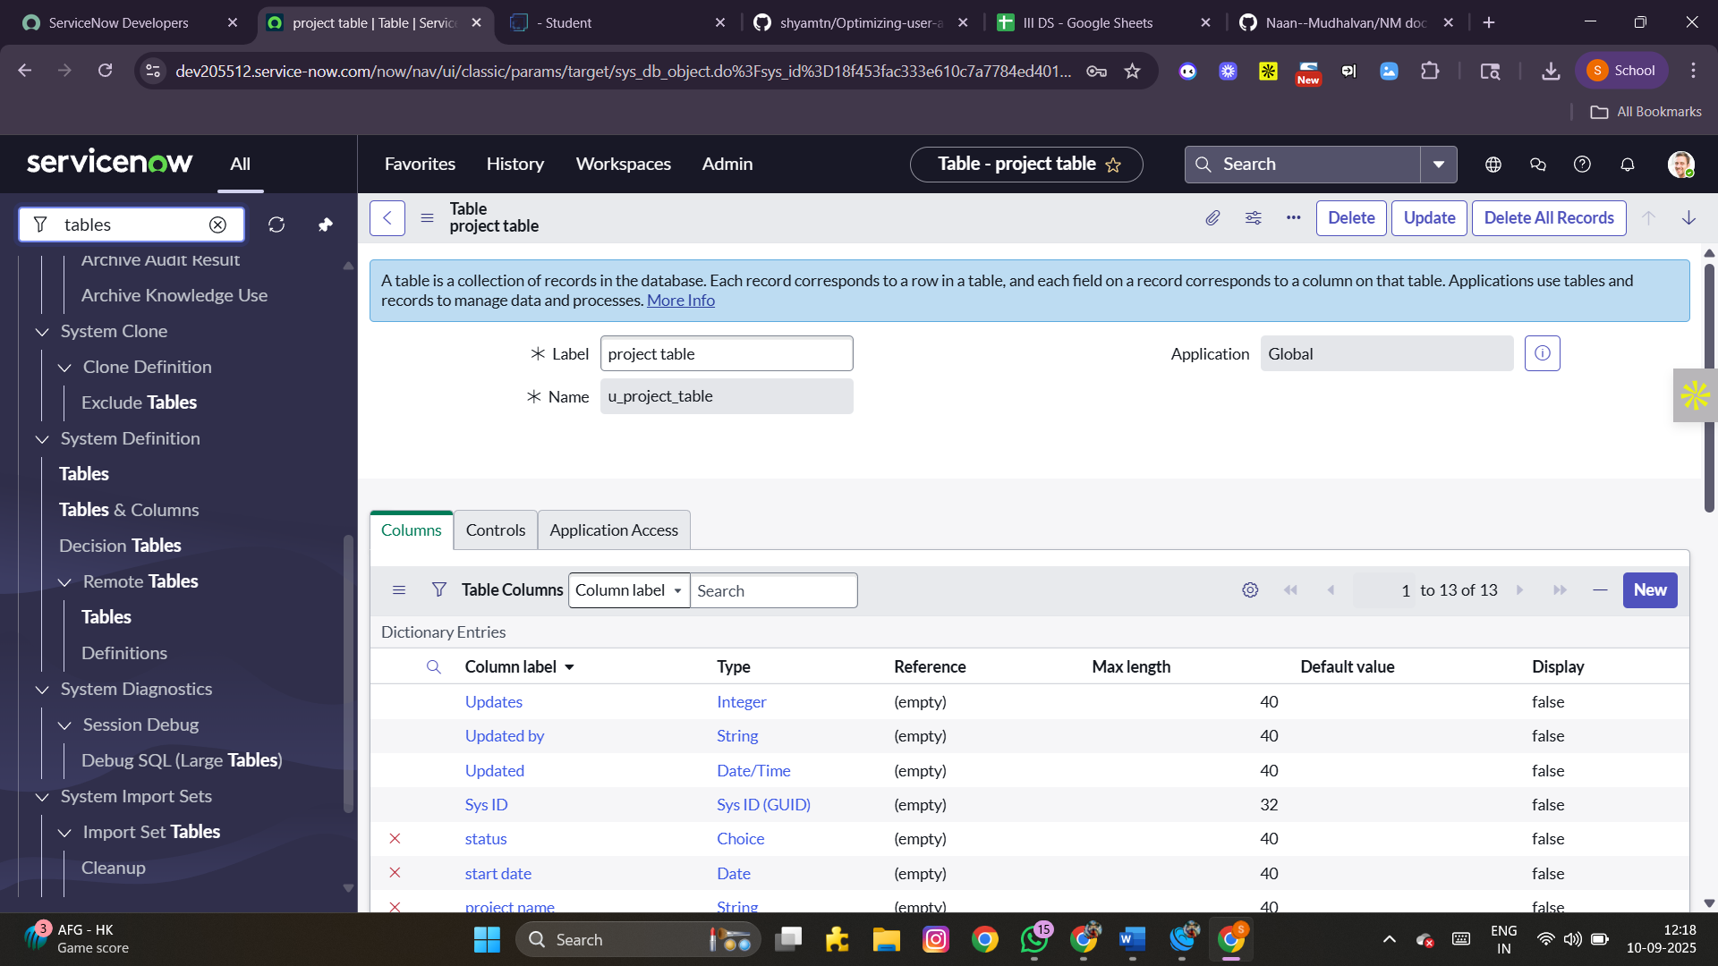 **Create an additional table:  
9. Add another table named *task table2*.  
10. Fill in the required details and click Submit.**

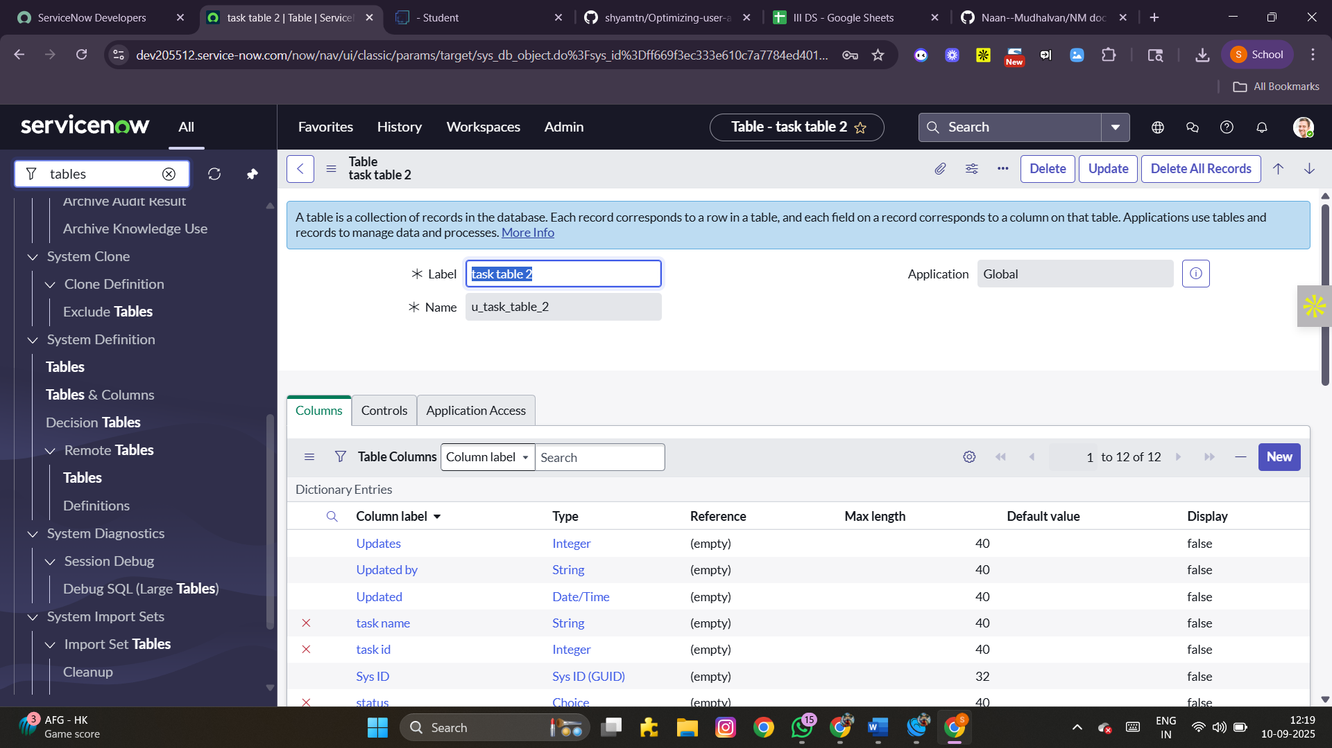

**Milestone 5: Assign Users to Groups**

**Activity 1: Assign Users to Project Team Group**

1. **In ServiceNow, navigate to All → Groups.**
2. **Select the Project Team Group.**
3. **Open the Group Members tab.**
4. **Click Edit.**
5. **Add *alice p* and *bob p* as members.**
6. **Click Save.**

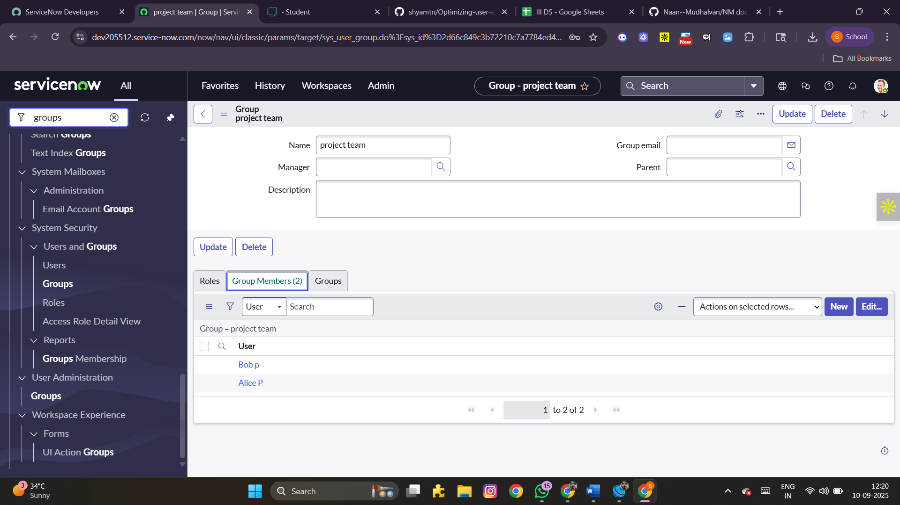

**Milestone 6: Assign Roles to Users**

**Activity 1: Assign roles to Alice (Project Manager)**

1. **Navigate to All → Users.**
2. **Select *alice p*.**
3. **Under the Roles tab, click Edit.**
4. **Assign the role *Project Member*.**
5. **Additionally, add roles: *u_project_table* and *u_task_table*.**
6. **Save and update the record.**

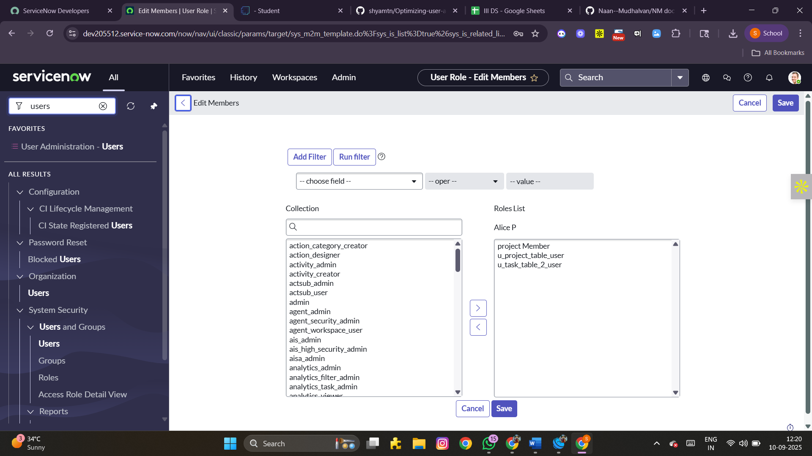 **Activity 2: Assign roles to Bob (Team Member)**

1. **Navigate to All → Users.**
2. **Select *bob p*.**
3. **Under the Roles tab, click Edit.**
4. **Assign the role *Team Member*.**
5. **Save changes.**

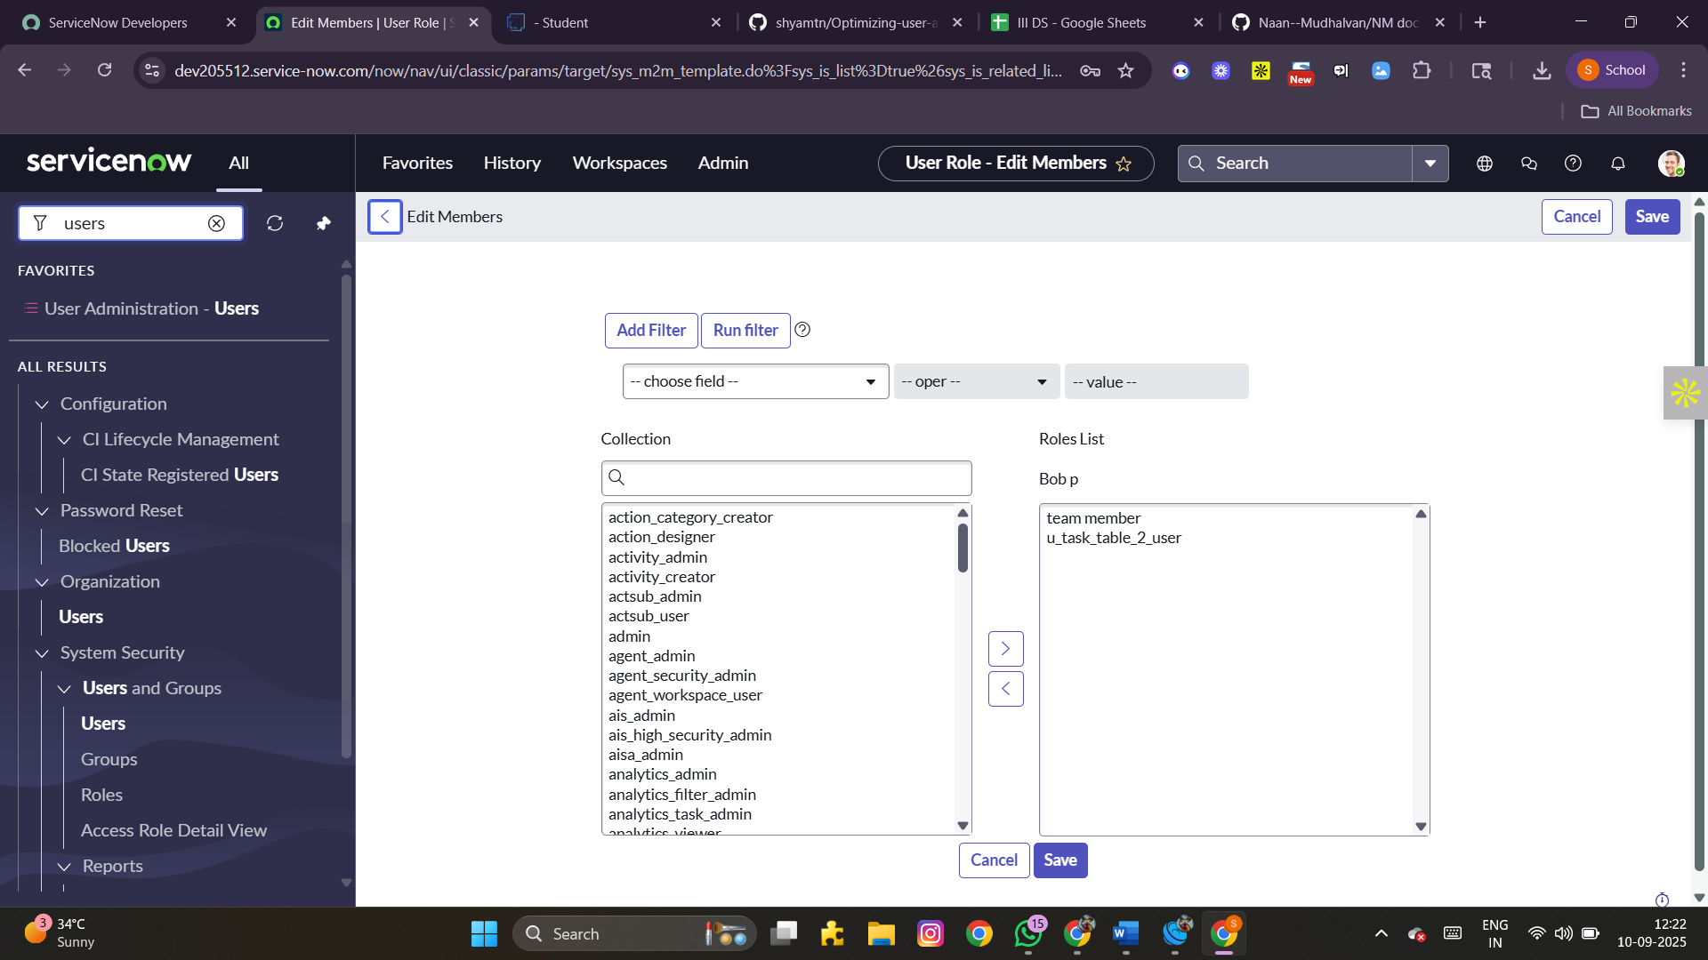

1. **Use Impersonate User → bob p to verify access.**
2. **Confirm that *task table2* is visible.**

**Milestone 7: Application Access**

**Activity 1: Assign Table Access to Applications**

1. **When a new table is created, ServiceNow automatically generates an application and module.**
2. **Search for the *Project Table* application in the Application Navigator.**
3. **Edit the module settings.**
4. **Grant access to the *Project Member* role.**
5. **Search for *task table2* in applications.**
6. **Edit the application and assign both *Project Member* and *Team Member* roles.**

**Milestone 8: Access Control List (ACL)**

**Activity 1: Create ACLs**

1. **Go to All → ACL.**
2. **Select Access Control (ACL) under System Security.**
3. **Elevate role (if required).**
4. **Click New.**
5. **Fill in the ACL details.**
6. **Under Requires Role, add a new row.**
7. **Assign *task table* and *Team Member* role.**
8. **Click Submit.**

**Create multiple ACLs:  
9. Repeat the process to create 4 additional ACLs for relevant fields.**

**Validation:  
10. Click the profile icon → Impersonate User.  
11. Select *bob p*.  
12. Navigate to task table2 in the Application Navigator.  
13. Verify that *Comment* and *Status* fields are editable.**

**Milestone 9: Flow**

**Activity 1: Build a Workflow using Flow Designer**

1. **Open Flow Designer (All → Flow Designer under *Process Automation*).**
2. **Click New → Flow.**
3. **Provide Flow Name: *task table*.**
4. **Select Application: *Global*.**
5. **Click Build Flow.**

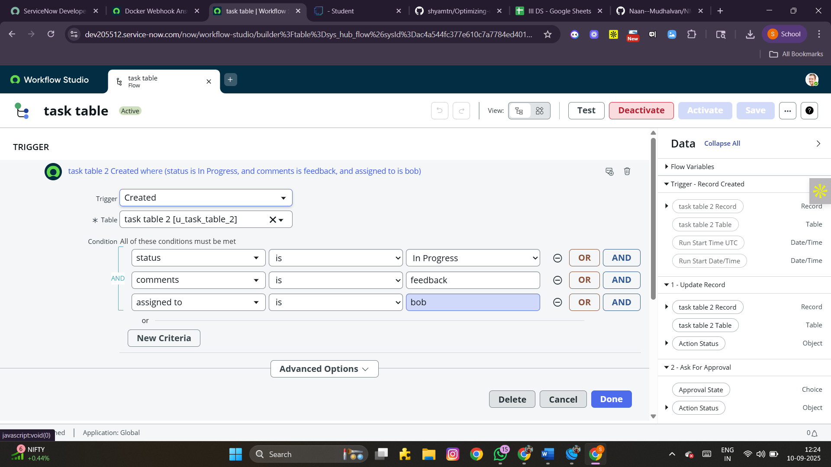 **Step 1: Add Trigger**

1. **Add a trigger → choose *Created Record*.**
2. **Table: *task table*.**
3. **Set conditions:**
   * **Status = In Progress**
   * **Comments = Feedback**
   * **Assigned To = bob**
4. **Click Done.**

**Step 2: Add Action – Update Record**

1. **Add an action → choose *Update Record*.**
2. **Select fields from Data Pills.**
3. **Set *Status = Completed*.**
4. **Click Done.**

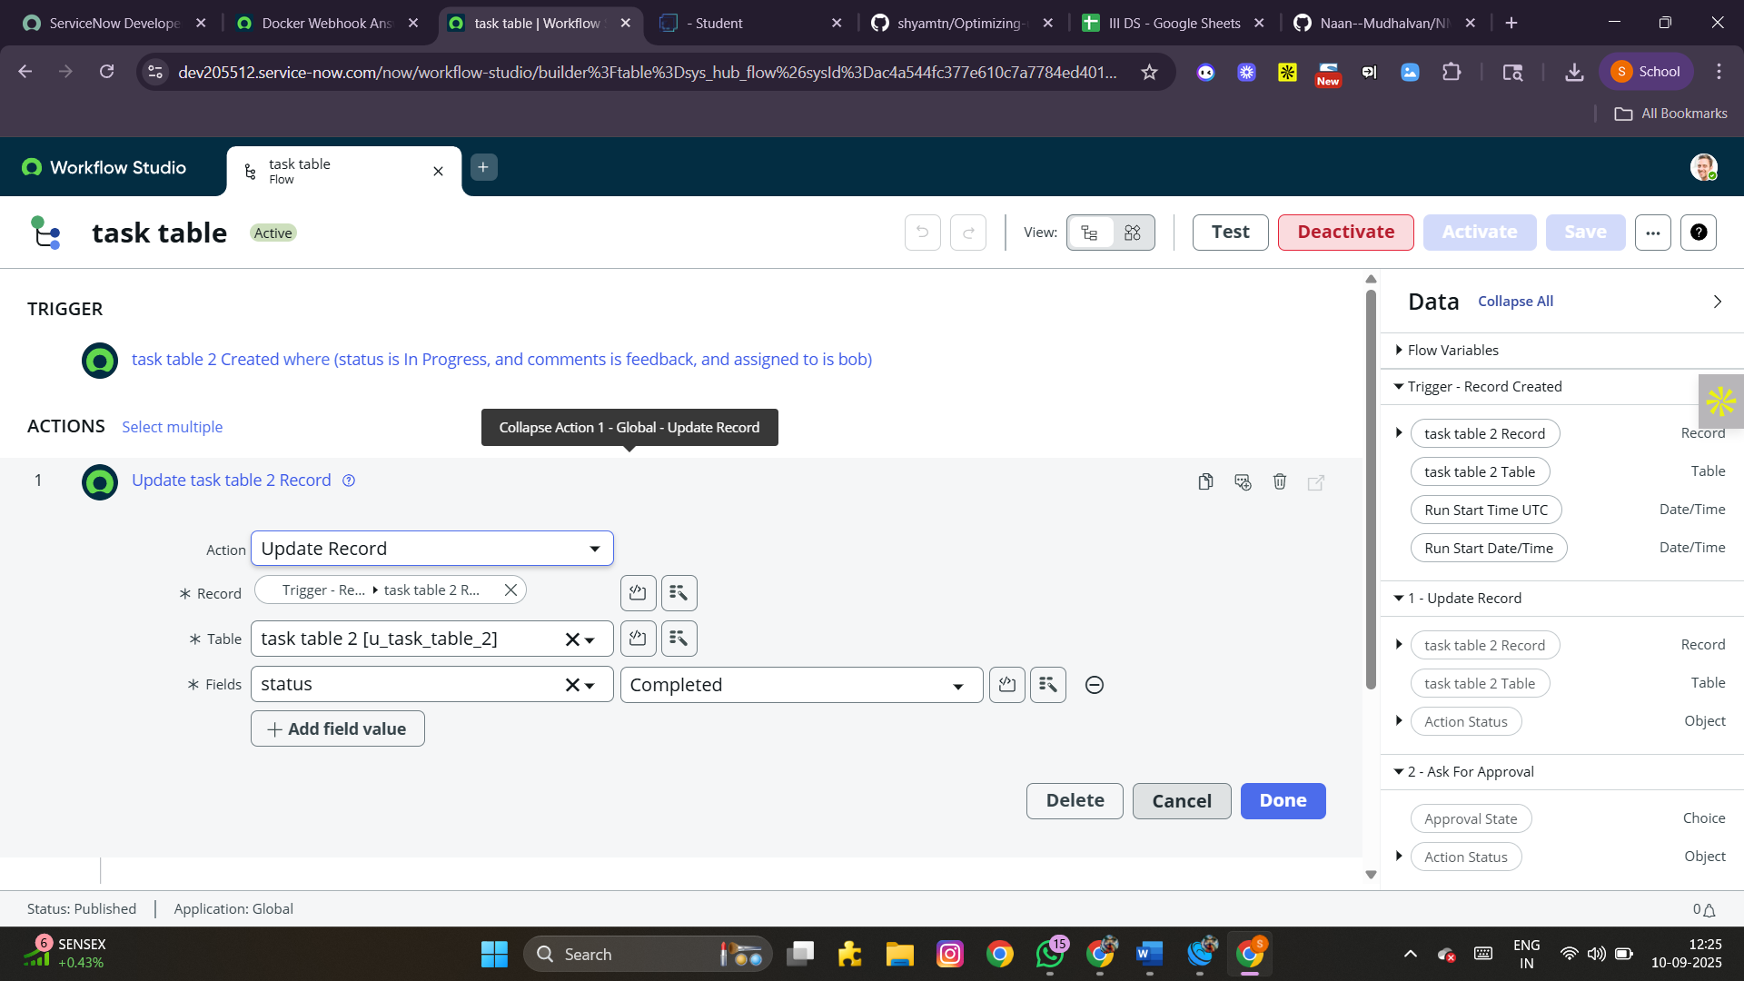 **Step 3: Add Action – Approval**

1. **Add another action → choose *Ask for Approval*.**
2. **Map required fields.**
3. **Set *Approval Field = Status*.**
4. **Approver = *alice p*.**
5. **Click Done.**

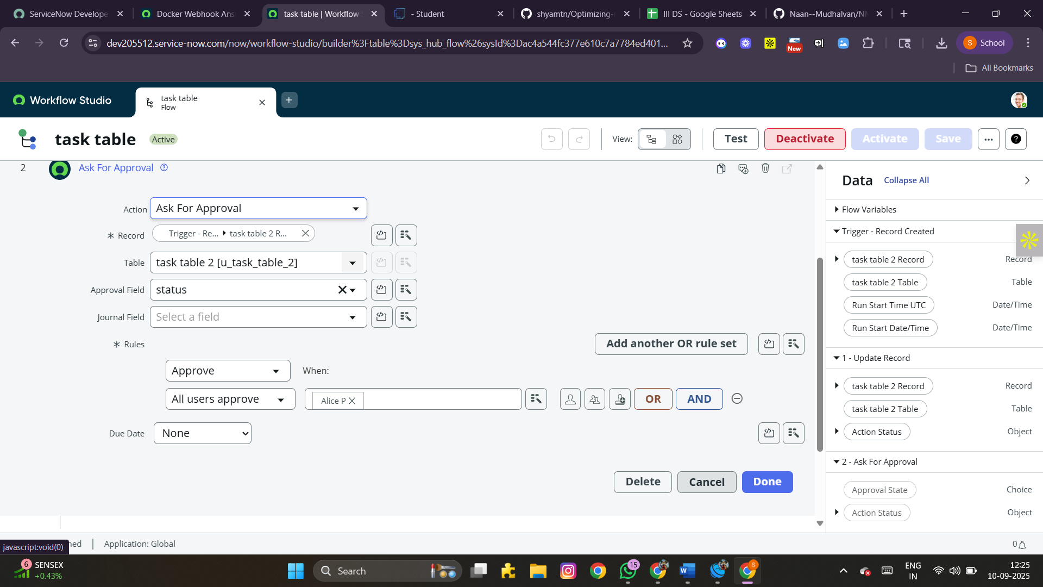 **Validation:**

1. **Go to task table2 application. Confirm that status updates to *Completed*.**
2. **Navigate to My Approvals under Service Desk.**
3. **Check that *alice p* receives the approval request.**
4. **Approve the request to complete the workflow.**

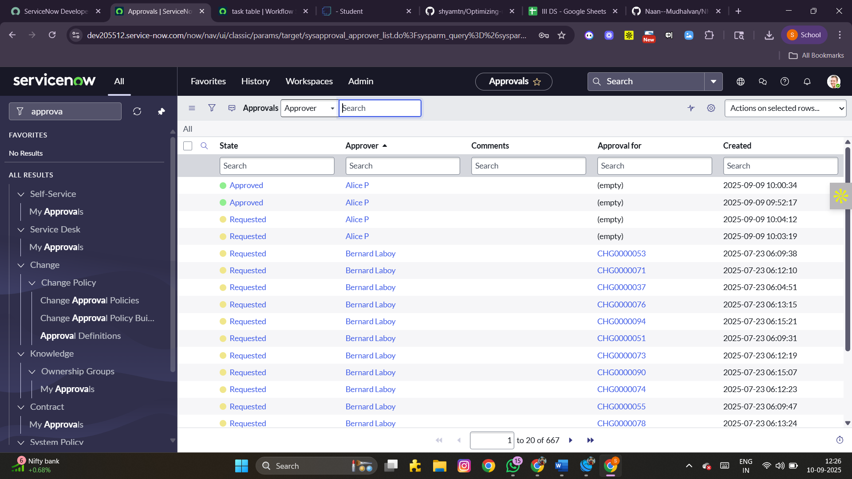

**Conclusion**

**Through this project, we successfully implemented a ServiceNow Workflow Management System. The key outcomes include:**

* **Structured creation of users, groups, and roles**
* **Proper assignment of application access and ACLs**
* **Automated workflows with approvals and status updates**
* **Verified access for multiple users with role-based permissions**

**This configuration demonstrates how ServiceNow can streamline IT operations, improve security, and automate repetitive tasks efficiently.**